
Panmure District School News
P O Box 14-249, Panmure
87 Mount Wellington Highway
Mount Wellington
Auckland, 1741
Telephone: 527 7659
Facsimile: 527 7089
Email: office@panmure.school.nz

No.02 - Term.4, Week 02 –Tuesday 24 October 2017

Greetings, Kia ora, Talofa lava, Kia orana, Malo e lelei, Fakalofa Lahi Atu, Namaste, An Young Haseyo, Konichiwha, Bula Vinaka, Sawadee, Dobra Dan, Ni Hao, As-salamu alaykum, Hola

Tokelauan Language Week
This week our school is celebrating Tokelauan language. Acknowledging cultural languages in school helps our students to recognise and respect other cultures.

Diversity Week

Thank you so much to the students who dressed in their ethnic wear to celebrate diversity language last week in school.

Winning House
Congratulations to the winning house Rata. As there were two winning houses this week, Puriri house flag will be flown on Thursday.
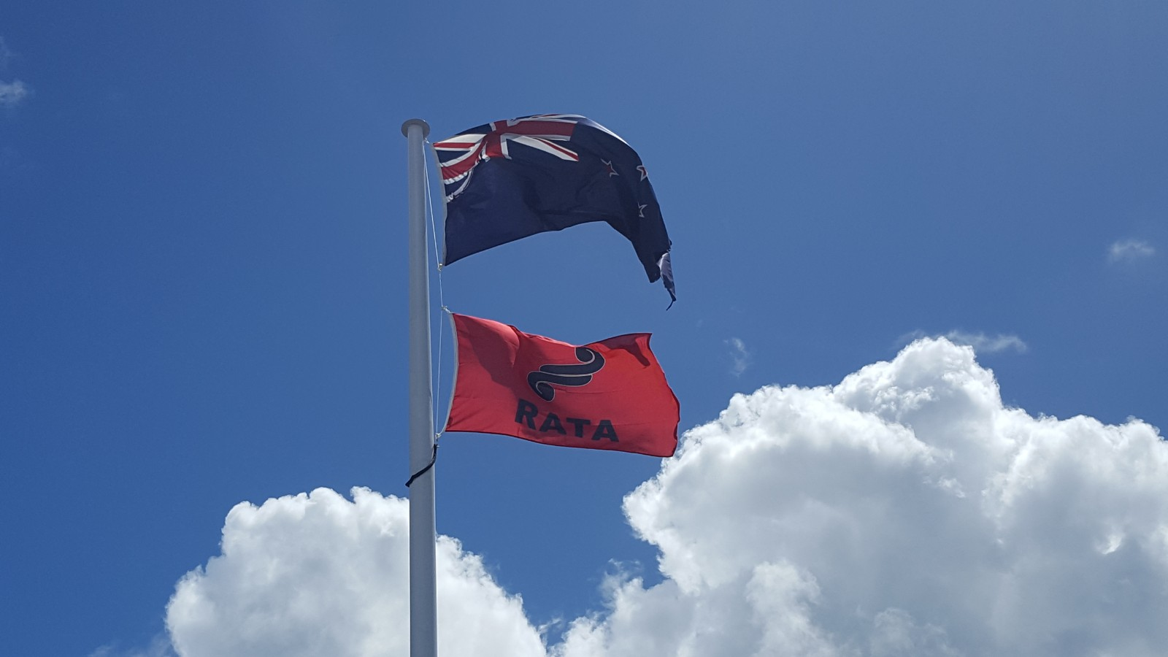

Auckland Touch Junior Trials
Just letting all our parents know that if you are interested in trialling your children for the Auckland Touch games please refer to the following information provided:

Junior Trials Under 10’s – Under 14’s

Date: Saturday 28th October 2017

Venue: Grey Lynn Park, off Elgin Street, Grey Lynn

PANMURE DISTRICT SCHOOL REUNION
A reminder to all families of current and ex-pupils to attend this lovely event. An exciting day to cherish memories of your school days at Panmure District School. If you are interested please contact the office for information on how to register. There will also be a special dinner and dance. The reunion is on Saturday 25 November.

Panmure District School Baking Programme

The baking programme starts at 9.00am every Wednesday in the school hall. Parents are welcome to share some of their amazing baking skills as well as socialise with each other.


School Breakfast Club
The breakfast programme runs daily in the school hall at 8.30am for all children who are interested in having breakfast. Parents are welcome to come along.

Upcoming Events –
Tamaki Zone Touch – Thursday 02 November
School Athletics – Friday 17 November
Ice Cream Day – Friday 17 November

Merit Awards –
Room 3 –
Leon Wu for strong development in writing.
Zaysharn Snowden for making strong progress in summarising.

Room 5 -
Riwai Hooper for making significant progress in reading and writing.
Monalisi Tupou for using her creative thinking to write narrative stories.

Room 6 –
Ana Kaufusi for showing improvement in comprehension skills.
Kartik Patel for showing improvement in writing skills.

Room 9 -
Misi Faitua for his good manners and settling into class.
Tayyab Faizi for his efforts to use word attack skills when spelling.

Room 10 -
Velinda Kaetau for making progress in counting on from largest number even when the smaller number is given first.
Hinano McQuade for being a very responsible iPad Monitor.

Environmental Award – Room 03
For working collaboratively with each other like a “whanau” inside and outside the classroom. A big achievement. Well done.

Duffy Book Awards –
Micaela Lizasoain for gaining independence in using comprehension strategies to comprehend the text.

Brooklyn Taufa for being a good friend.

Rihari Turner for participating well and striving to show RISE in all areas.

Marshall Hepana for showing towards others.


Faiva Helu for his good efforts to be seeing following class routines.

